Saboteur Simulator

Use-Case Model

Version 2.0

Revision History

|  |  |  |  |
| --- | --- | --- | --- |
| **Date** | **Version** | **Description** | **Author** |
| 18/03/2016 | 1.0 | Added 3 UML diagrams and 3 use-cases | Iulia Ungur |
| 27/05/2016 | 2.0 | Renewed diagrams for new requirements | Iulia Ungur |
|  |  |  |  |
|  |  |  |  |

Table of Contents

1. Use-Cases Identification 4

2. UML Use-Case Diagrams 5

Use-Case Model – version 1

# Use-Cases Identification

Use case: UserExperience

Level: user-goal level

Primary actor: Registered or Unregistered User

Main success scenario: User registers, logs in, creates a game, joins one or spectates

Extensions: user can stay and chat with others without participating in a game

Use case: FeatureActivity

Level: summary level

Primary actor: User

Main success scenario: Reaches a decision and enters a game (regardless of the position in it)

Extensions: in case of failure: returned to lobby

Use case: IdentificationAndParticipacion

Level: sub-function

Primary actor: Client

Main success scenario: Client logs in with success, watches lobby current status, joins a game

Extensions: if failed to log in: registration is available; if user wants to quit game: leave game is available

# UML Use-Case Diagrams

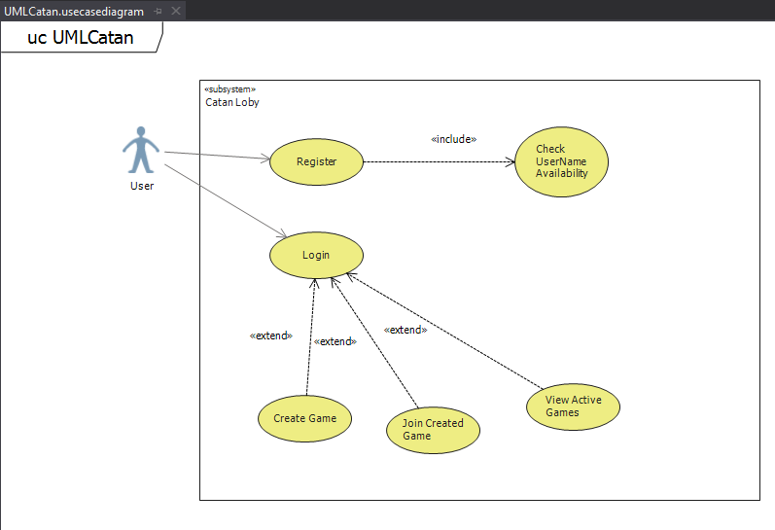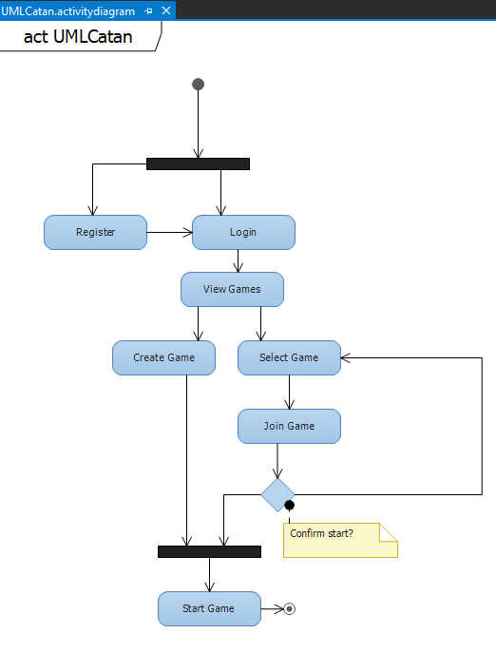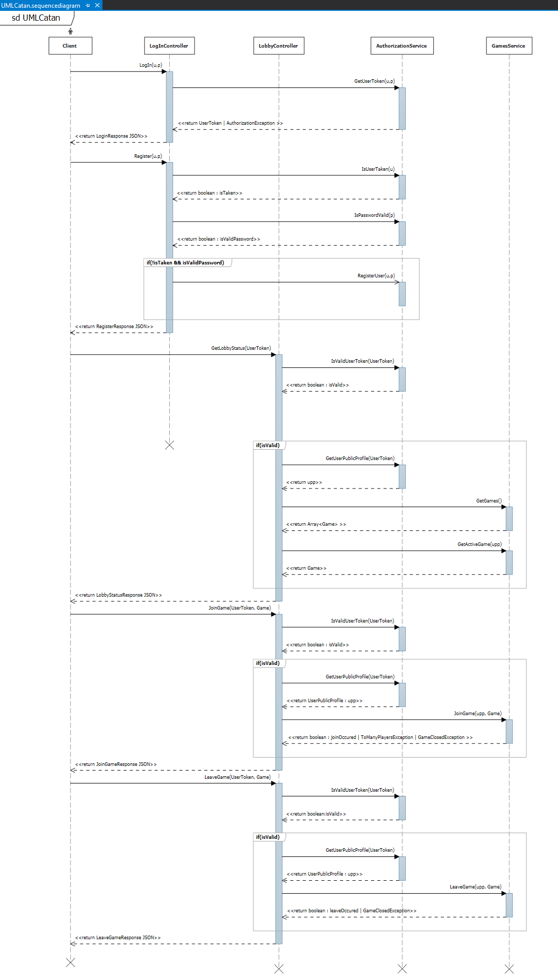

Use-Case Model – version 2

# Use-Cases Identification

Use case: UserExperience

Level: user-goal level

Primary actor: Identified user

Main success scenario: User identifies himself, creates a game and starts it

Extensions: user can make a move or stand by till other user makes his

Use case: FeatureActivity

Level: summary level

Primary actor: User

Main success scenario: Reaches a decision and enters a game (regardless of the position in it)

Extensions: in case of failure: returned to lobby

Use case: IdentificationAndParticipacion

Level: sub-function

Primary actor: Client

Main success scenario: Client identifies with success, watches lobby current status, joins a game

Extensions: if user wants to create a game, he can from lobby

# UML Use-Case Diagrams

